|  |
| --- |
| rEGGAErunningz LIMITED |
| 2D PLATFORMER |
| **GAME PROGRAMMING1 ASSIGNMENT2** |
| Version 1.03  All work Copyright © 2015 by ReggaeMuffinz Games.  All rights reserved. |
| **HuAndre Barrett** |
|  |



**Insert a Company Logo here**

|  |
| --- |
| Oct 26th 2015 |

**Table of Contents**

Contents

Version History 3

Game Overview 4

Game Play Mechanics 4

Camera 4

Controls 4

Menu and Screen Descriptions 5

Enemies 5

Items 5

Vehicles 5

Script 6

Scoring 6

Sound Index 6

Art / Multimedia Index 6

Future Features 6

# Version History

The Github repository can be found here https://github.com/cencolhubar/2D-Platformer

# Game Overview

*The game consists of an Indian chief who is running and trying to hunt the flock of birds that are flying in the open lands. While the birds are flying there are bats intermingled with them which damage the Indian chief if he collides with them. Also as an added level of difficulty the ground falls away as the chief steps on it. The object of the game is for the player to catch the birds and avoid the bats without falling into the abyss.*

# Game Play Mechanics

*The game automatically gives the illusion of side scrolling by looping the texture around the quad background. You can use the left, right, up or down arrow to move the player in any direction. As you move around you will see birds and bats appearing on the screen as it scrolls. Use the arrow keys to touch the birds and they will disappear. You will also see the bats flying towards you intermingled with the birds. Use the arrow keys to avoid them. When birds are collected your points increase. Your points are displayed on your screen as you play. When you collide with a bat you lose a life. When you lose three lives you die. The option to restart your game by pressing the R button shows up on the screen when you die.*

# Camera

*Side Scrolling view perspective*

# Controls

*Arrow keys to direct the Indian Chief*

# Menu and Screen Descriptions

*IN GAME SCREENSHOT*

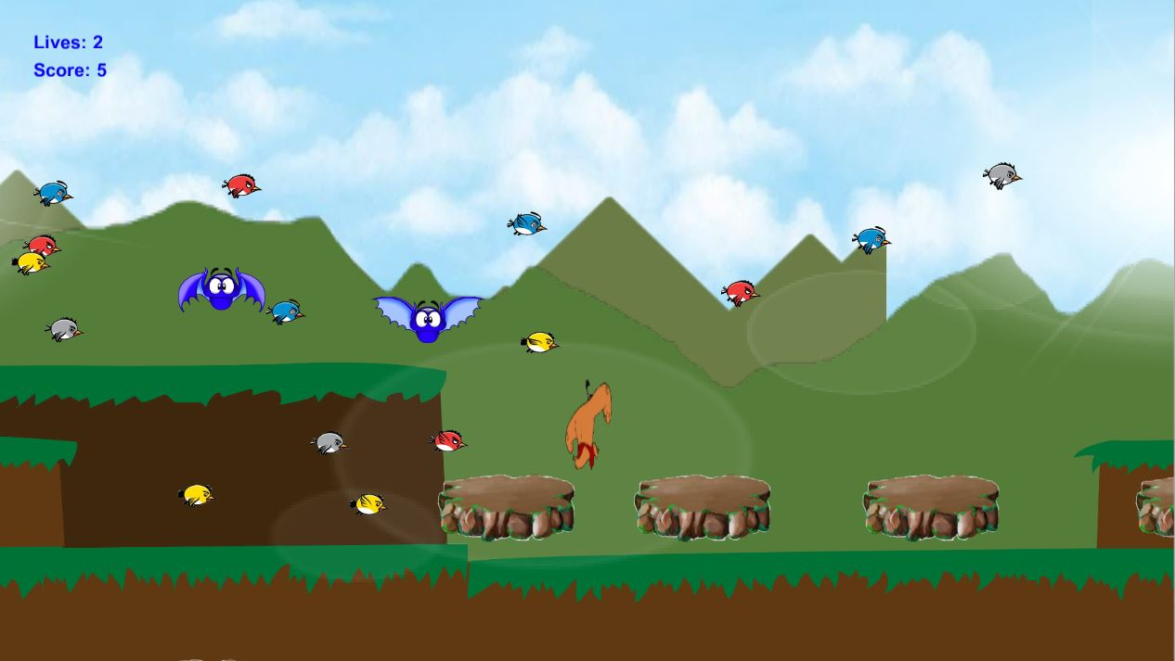

*POST GAME SCREENSHOT*

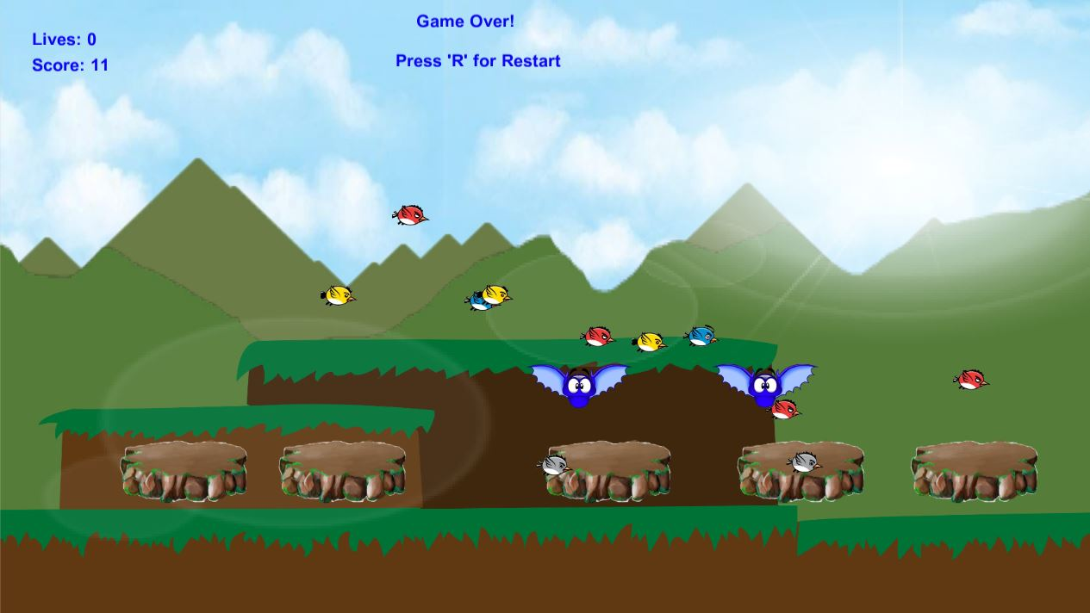

*PRE GAME SCREENSHOT*

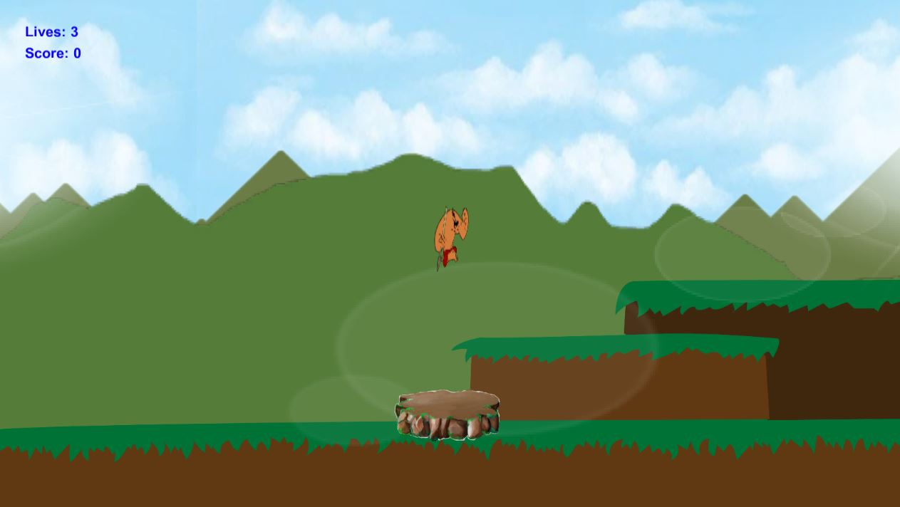

Main and only game screen

# Enemies

*The hazards that can kill the player if collided with are the bats*

# Items

*The Indian Chief collects birds to increase his score*

# Player

The main player is the Indian chief

# Script

..\ SpaceShooter-master\Kissmyapp\Assets\Scripts

# Scoring

Player points increase by 1 each time they collect a bird

# Sound Index

..\ SpaceShooter-master\Kissmyapp*Assets\Audio*

* **Taken from Youtube**
  + Background drumming soundtrack - 1 Hour of Best Relaxing Music - African Drums (djembe, dunumba, instrumental)
* **Taken from Unity Asset Store**
  + Indian Chief death/falling into abyss sound (Attack Jump & Hit Damage Human Sounds)
  + Bird flapping wings sound (Jungle Animal Sound FX)
  + Bat collision sound (Jungle Animal Sound FX)
  + Collect bird sound (Jungle Animal Sound FX)

# Art / Multimedia Index

*The following graphic assets were taken from unity 3d store from the following resources*

* Indian hero
  + Free Maya Indian Hero (*Unity 3d store)*
* Bat
  + http://www.moddb.com/games/gooing-up/images/small-blue-enemy-spritesheet
* The scrolling background asset
  + https://lh3.googleusercontent.com/KxOSHh-Rc1TedBgPqdjXZi9e_ON9elMZY1hw3TTLbbTEbvZKsPjTxU48TeYU84QhMNkwGYQ=s170
* Ground
  + https://lh3.googleusercontent.com/jrLDMYPiKigDJMEO443Uz8mHGh2WZDAUlMkxpeBYYW5mjU0-ue0WaOXrk8Omg4cuYk7w8A=s151
* Bird
  + https://encrypted-tbn1.gstatic.com/images?q=tbn:ANd9GcSLFnY5r83vOucAX6kCwHm4YA_Ve94F0sk3BnlnN0BBcKKEgOnhZA

# Future Features

*Implementation of the Indian chief shooting arrows to kill the bats*